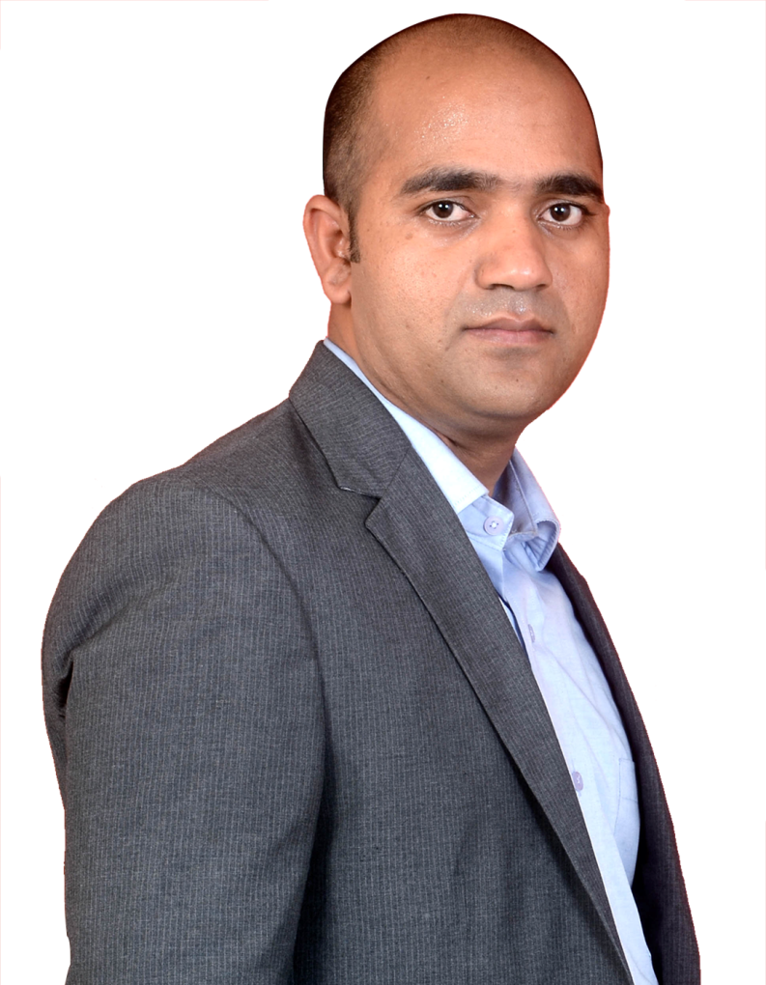 **About us**

English today is not just a language a ladder to success in one’s professional as well as personal life. As the various surveys suggest today’s youths are not getting deserved position in their professional lives, even though they are technically adept. English becomes the biggest hurdle on their way to success. Same is the case with the majority of the students, who are often found struggling, when it comes English Language. Lingua Franca has a team qualified and trained professionals who have exceptionally high level of commitment towards training and their work. Mohammad Ali the Founder and Director, who is immensely experienced and having more than a decade of training experience, studded with the professional brilliance predominantly in the field of English Language, Voice & Accent, and Soft Skills training. Trained people from corporate, students, kids, housewives and handled various training projects. During these years of training career he has worked with MNCs and people from abroad, which offered him a great chance to learn the nitty gritty of the training. Now stands with a proven track record of training and made significant changes in the lives of the people those who underwent the training programs, and his continuous research in training module and updated methodology has helped many in living their dreams and many language proficient test takers like, IELTS, TOEFL and PTE. We provide a sophisticated environment and personalised attention to learners, under the guidance of Mohammad Ali, which helps them to naturally speak English, as his mission is to make India a Skilled India.